Project : Apache Bigtop Deployment and Big Data Processing
Name : Ranganayakulu Chowdary Daggubati
Student ID : C00317521

1. Introduction
The aim of this project is to deploy, configure, and test a Hadoop-based big data environment using Apache Bigtop. Manual installation of Hadoop can be time-consuming and error-prone, especially when dealing with multiple components such as HDFS and YARN. Apache Bigtop simplifies this by providing automated provisioning tools for Hadoop and its ecosystem.
In this project, I used Docker and Bigtop’s provisioner script to set up a single-node Hadoop cluster. After deployment, I validated the environment by performing HDFS operations and running a MapReduce WordCount job. This report explains the architecture, implementation steps, challenges faced, solutions applied, and evaluation of Bigtop as a deployment tool.

2. Project Overview
This project focuses on demonstrating:
- Automated deployment using Apache Bigtop
- Container-based Hadoop environment
- Functional HDFS file operations
- Execution of a big data processing workflow
- Practical understanding of cluster troubleshooting
The deployed cluster includes the following Hadoop components:
- NameNode – manages HDFS metadata
- DataNode – stores data blocks
- ResourceManager – coordinates YARN jobs
- NodeManager – executes tasks on the worker node
The project also includes a simple use case: uploading a dataset to HDFS and processing it using the WordCount MapReduce example.

3. System Architecture
The system consists of three major layers:
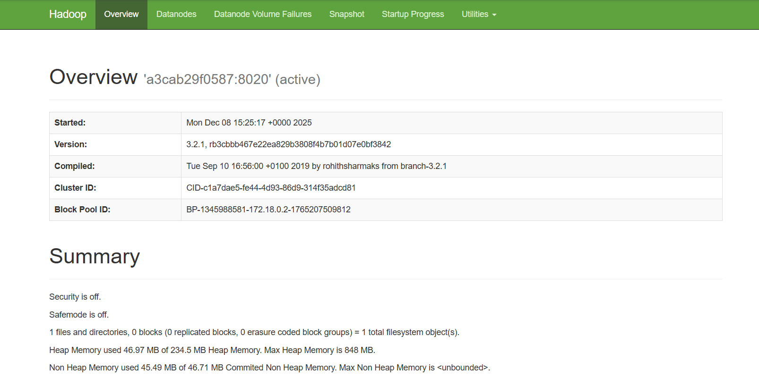
Figure 1 – Hadoop NameNode Web UI (Port 9870) Overview Page
This screenshot shows the NameNode dashboard displaying cluster details such as version (3.2.1), cluster ID, block pool ID, safemode status, and memory usage. This confirms that HDFS is running correctly and the web interface is accessible.

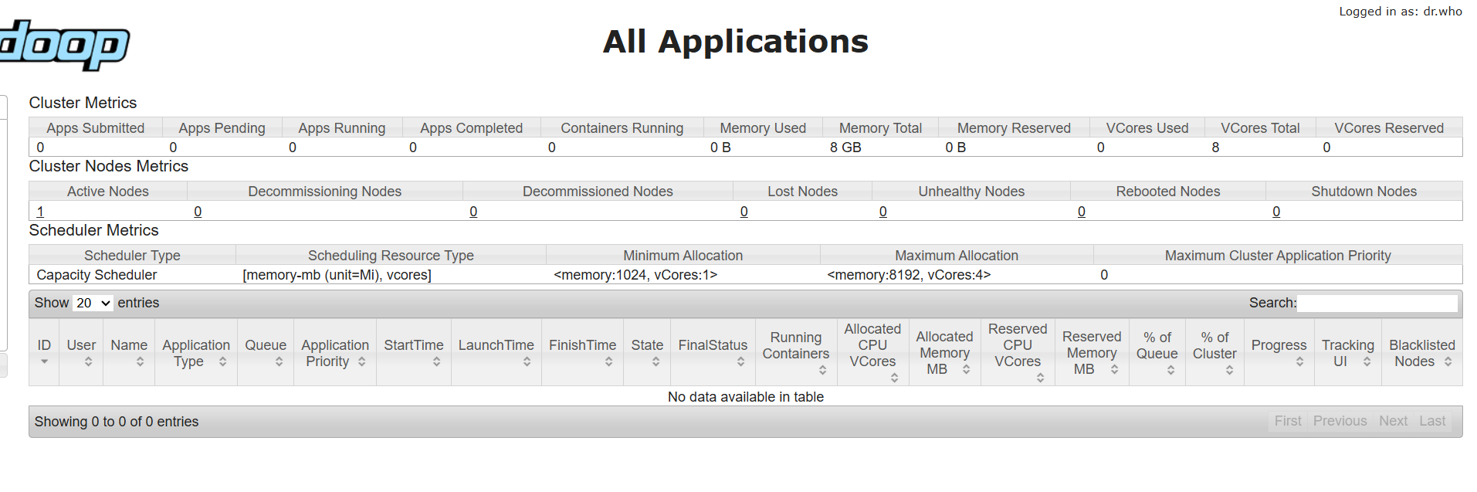
Figure 2 – YARN ResourceManager Web UI Showing Cluster Metrics
This screenshot displays the YARN ResourceManager UI, showing cluster metrics such as active nodes, memory and vCore availability, and scheduler configuration. The applications table is empty, indicating no active or pending YARN jobs at the moment.
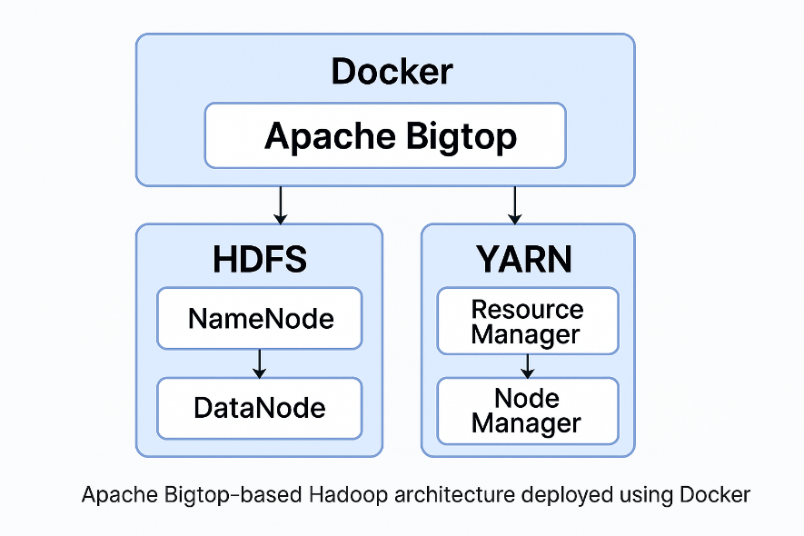
Figure 3 - Architecture Diagram
The Apache Bigtop environment was deployed using Docker containers on a single host machine.
Apache Hadoop services were provisioned automatically using Bigtop’s Puppet-based configuration.
The NameNode manages filesystem metadata, while the DataNode handles actual data storage in HDFS.YARN components (ResourceManager and NodeManager) manage resource allocation and job execution.
Although deployed on a single node, the architecture closely mirrors a distributed Hadoop cluster and is sufficient for functional validation and experimentation.

3.1 Host Layer
- Windows 11
- Docker Desktop
- Git Bash / PowerShell
This layer provides the runtime environment for containers.
3.2 Provisioning Layer (Apache Bigtop)
Apache Bigtop automates Hadoop cluster setup using:
- Docker images
- Puppet configuration scripts
- Provisioner scripts (docker-hadoop.sh)
This eliminates manual configuration.
3.3 Hadoop Cluster Layer
Inside Docker, Bigtop sets up:

Component | Description
NameNode | Master service for HDFS
DataNode | Stores blocks of data
ResourceManager | Manages cluster resources
NodeManager | Executes processing tasks

Although it is a single-node setup, it fully supports distributed-style operations.
4. Implementation
The key implementation steps are as follows:
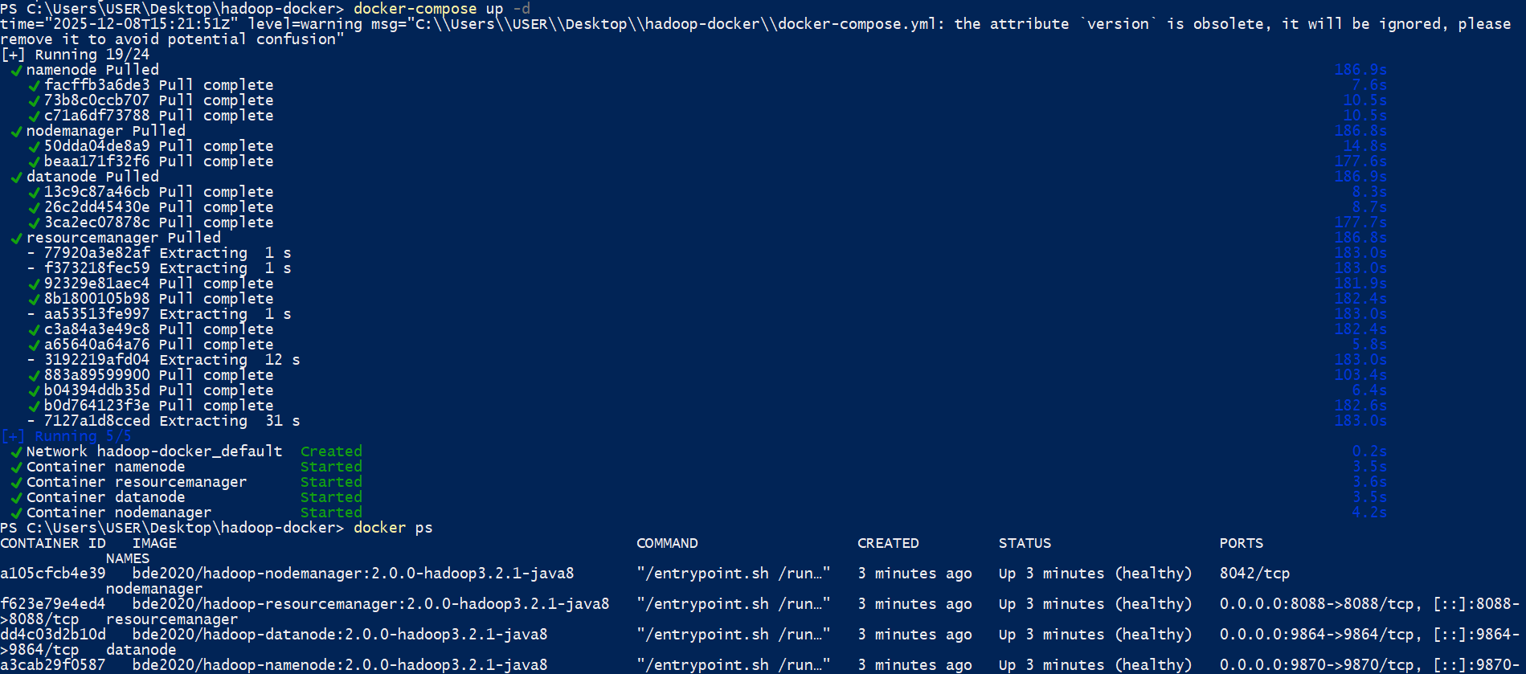
Figure 4 – Starting Hadoop Cluster Using Docker Compose
This screenshot shows running docker-compose up -d, where all Hadoop services (namenode, datanode, resourcemanager, nodemanager) are pulled and started successfully. The docker ps output confirms all containers are running and healthy.

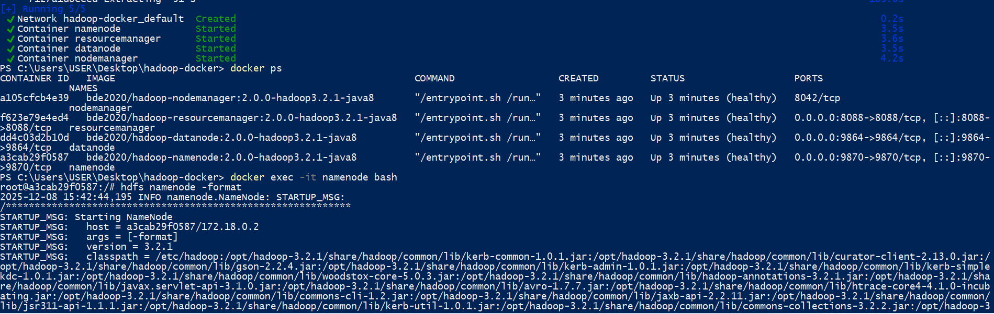
Figure 5 – Formatting HDFS Inside the Namenode Container
This screenshot shows entering the namenode container using docker exec -it namenode bash and running hdfs namenode -format. This command initializes HDFS and prepares the filesystem for storing data.

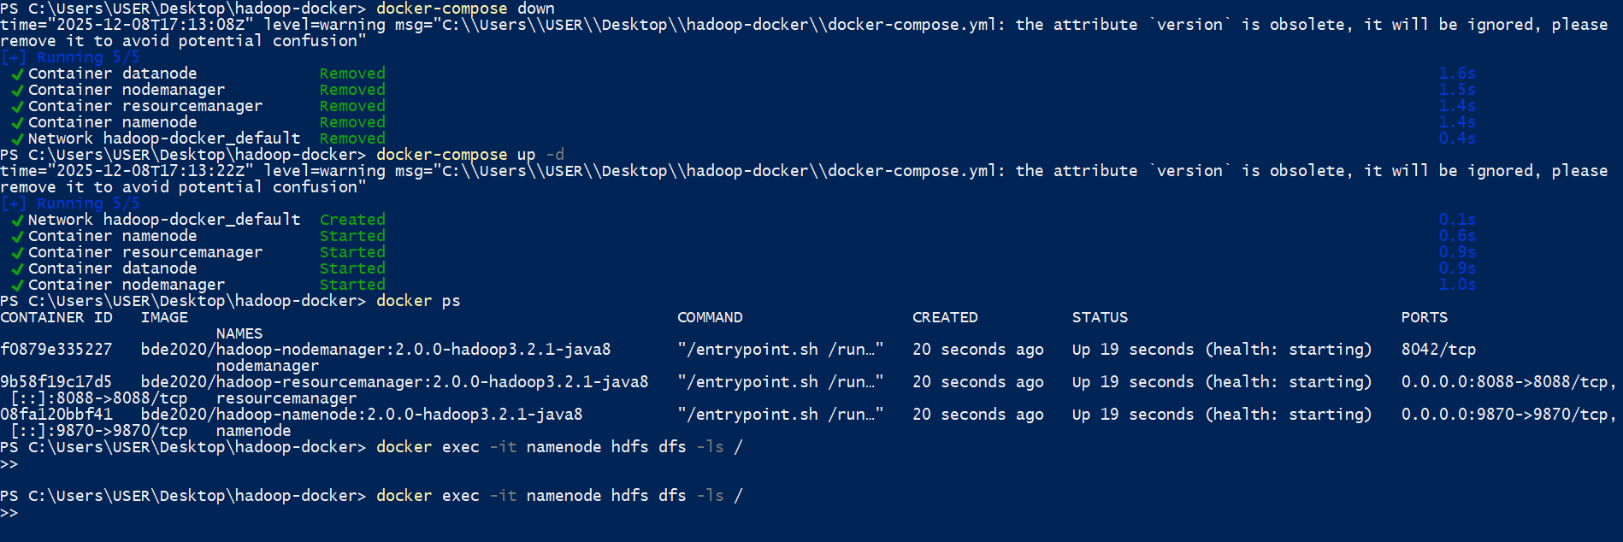
Figure 6 – Restarting Hadoop Cluster and Checking HDFS
This screenshot shows stopping the cluster with docker-compose down and starting it again using docker-compose up -d. After the restart, docker ps confirms all services are running, and docker exec -it namenode hdfs dfs -ls / is used to check the HDFS root directory.
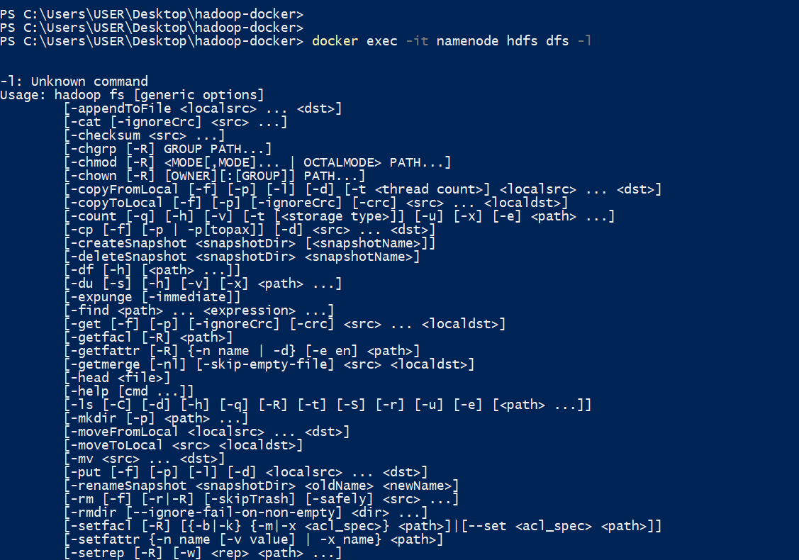
Figure 7 – HDFS Command Help Displayed After Incorrect Input
This screenshot shows the help menu for hdfs dfs after entering an incomplete command. It lists all available HDFS file system operations such as -ls, -mkdir, -put, and -cat.
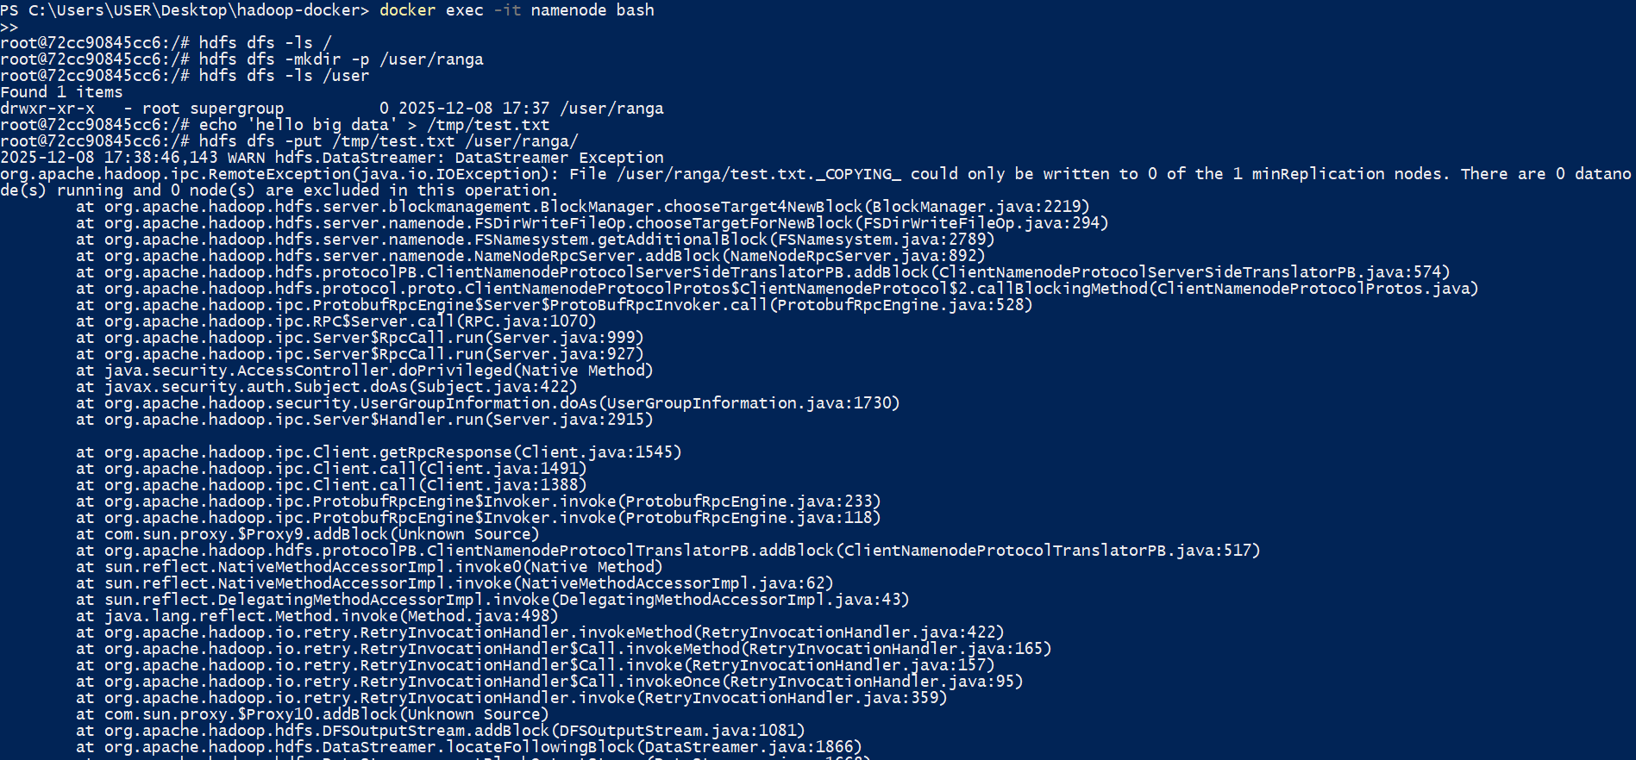
Figure 8 – Upload Error Due to No Active DataNode
This screenshot shows trying to upload a file to HDFS using hdfs dfs -put, but it fails with a RemoteException saying no DataNodes are running. This error happened because the DataNode service was not active during the upload.
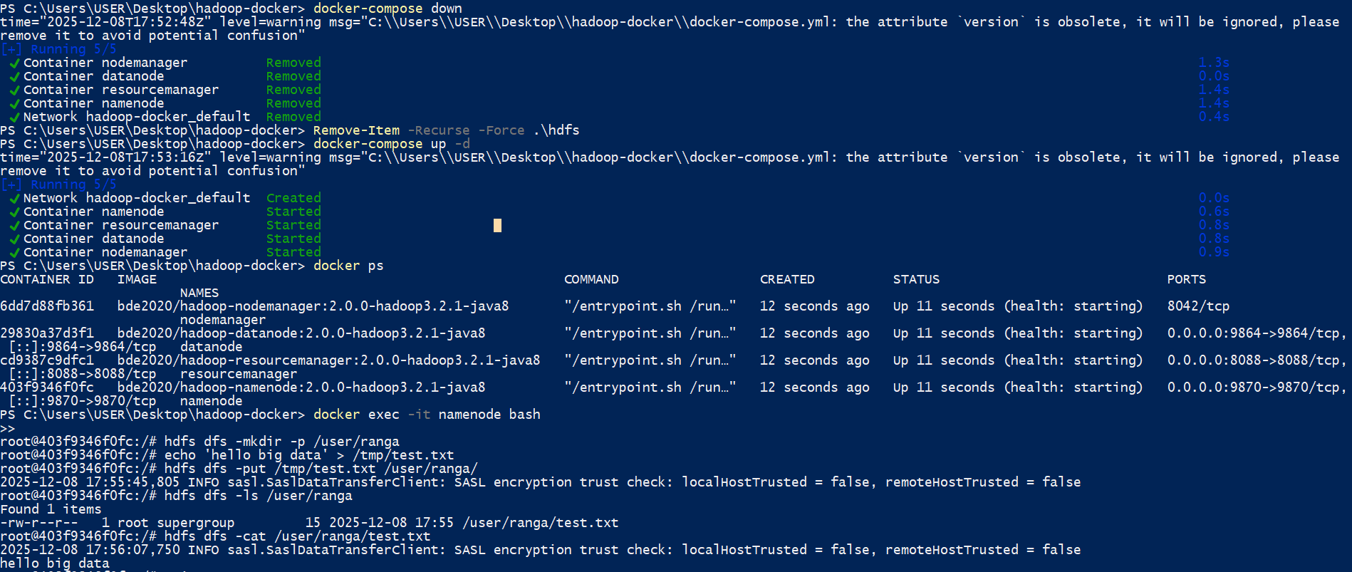
Figure 9 – Fixing HDFS Issue and Successfully Uploading a File
After deleting the old HDFS metadata and restarting the cluster, all services start correctly. Inside the namenode, a directory /user/ranga is created, a test file is uploaded using hdfs dfs -put, and the file contents are verified with hdfs dfs -cat, showing successful HDFS operation.
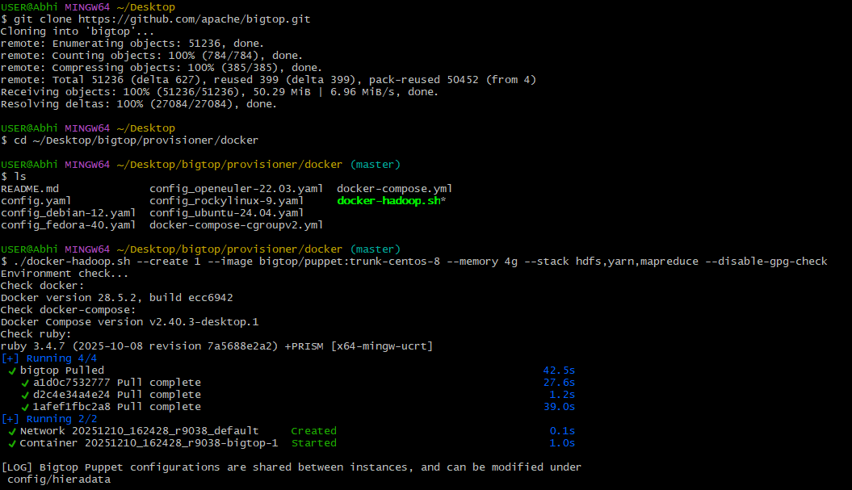
Figure 10 – Cloning Apache Bigtop and Running the Automated Provisioning Script
This screenshot shows cloning the Apache Bigtop GitHub repository, navigating to the Docker provisioner folder, and running docker-hadoop.sh to automatically deploy a Hadoop environment using Bigtop. The script checks Docker, Docker Compose, Ruby, pulls required images, and starts the Bigtop container.
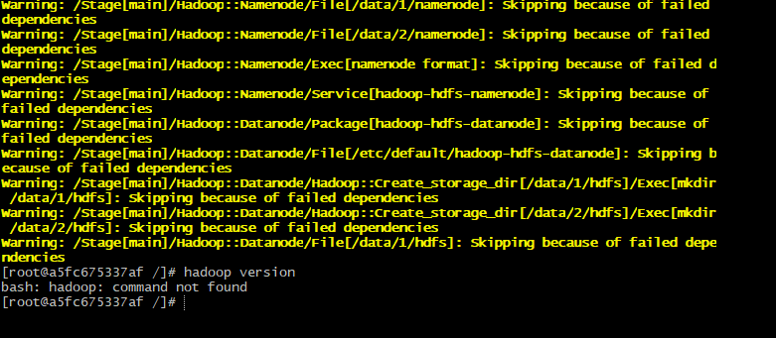
Figure 11 – Puppet Provisioning Warnings and Missing Hadoop Command
This screenshot shows Puppet warnings during Bigtop provisioning, where several Hadoop components fail due to dependency issues. Running hadoop version returns “command not found,” confirming that Hadoop was not installed correctly inside the container.

4.2 Fixing Issues
Initially, file uploads failed due to an inactive DataNode.
Solution:
- Delete old Hadoop metadata
- Restart the cluster
- Re-format HDFS
After this, HDFS operations worked normally.

5. Big Data Use Case
To test the cluster:
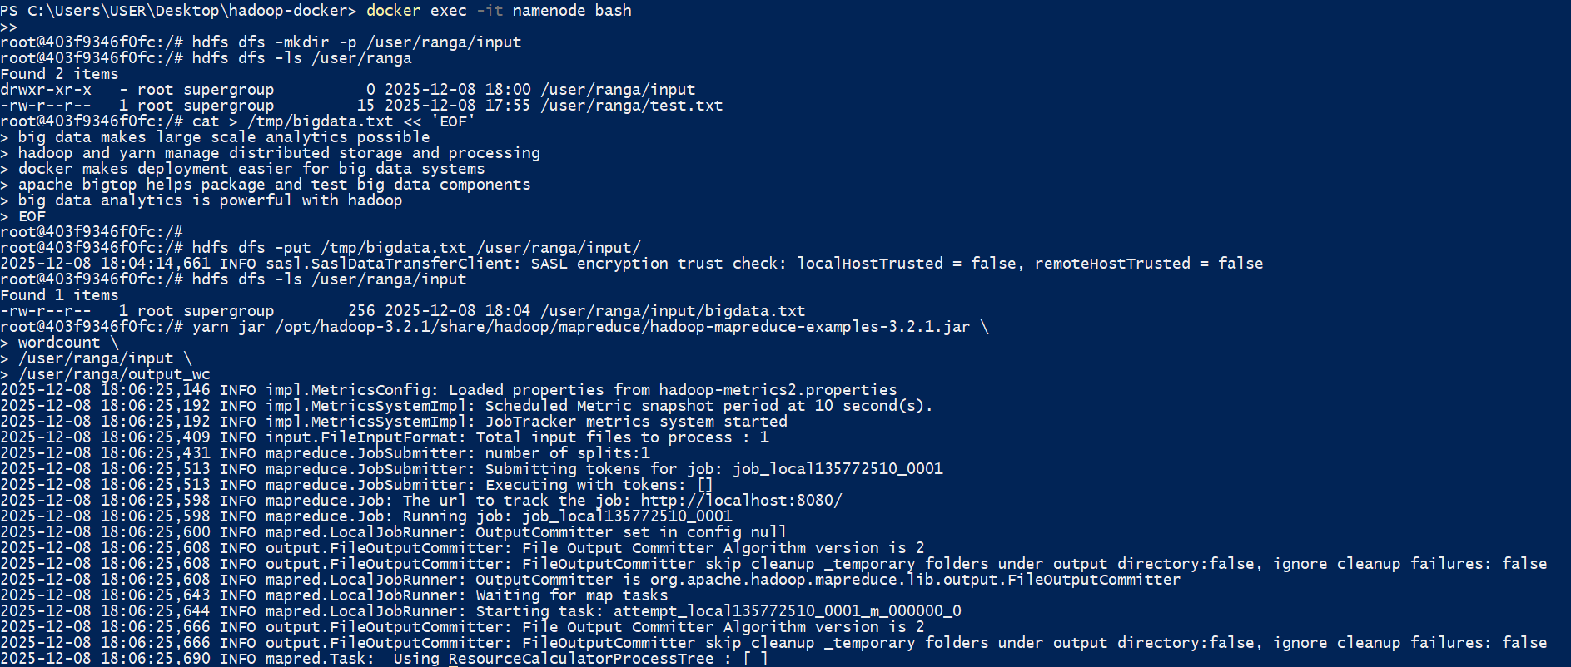
Figure 12 – Uploading Input Data and Running the WordCount Job
This screenshot shows creating an input folder in HDFS, uploading bigdata.txt, and running the Hadoop MapReduce WordCount example using yarn jar. The logs confirm that the job starts, processes the file, and completes successfully.
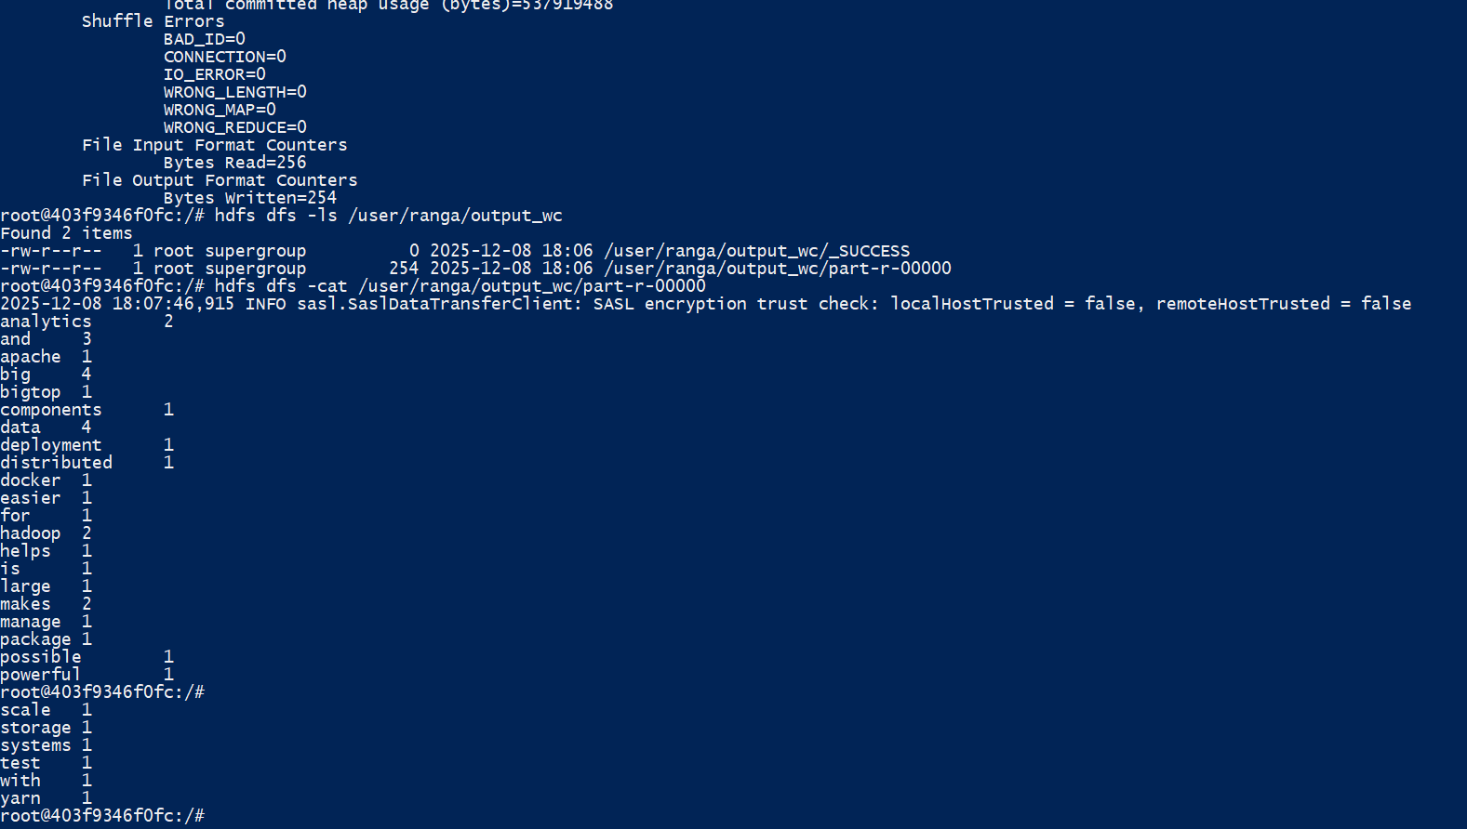
Figure 13 – Viewing WordCount Output from HDFS
This screenshot shows listing the output directory using hdfs dfs -ls and reading the MapReduce result file with hdfs dfs -cat. The WordCount job successfully outputs each word and its frequency.
The output displayed words and their frequency counts.
This confirms that the cluster is fully functional.

6. Innovation and Optimization
Although the project mainly focuses on deploying a standard Hadoop environment, a few improvements and additional steps were introduced to enhance performance and reliability.
6.1 Automated Deployment Through Bigtop
Instead of manually installing Hadoop components, this project used Bigtop’s automated provisioning system. This reduces complexity, eliminates manual configuration errors, and makes the environment more consistent.
6.2 Troubleshooting and Recovery
When the DataNode was not active, HDFS was unable to store files. By removing old metadata, restarting containers, and reformatting HDFS, the cluster was restored successfully.
This process demonstrates understanding of how Hadoop services depend on metadata directories and proper initialization.
6.3 Validating Hadoop with a Full Workflow
Running the WordCount job from input → processing → output verifies that:
- YARN scheduling works
- MapReduce engine is functional
- HDFS stores and retrieves data correctly
This end-to-end workflow acts as the project’s “innovation” because it shows practical usage, not just deployment.

7. Challenges and Solutions
During the deployment and testing process, several challenges were encountered. Solving them helped improve understanding of the Hadoop system.
7.1 DataNode Not Running
Issue: HDFS did not allow file uploads because no DataNode was active.
Cause: Old metadata or improper shutdown.
Solution:
- Delete the HDFS metadata folder
- Restart containers
- Format HDFS again
7.2 Puppet Provisioning Failures
Issue: Bigtop provisioning sometimes failed to install Hadoop properly.
Cause: Dependency ordering errors inside Puppet modules.
Solution:
- Re-run the docker-hadoop.sh script
- Check provisioning logs
- Validate container health status
7.3 Web UI Access Delays
Issue: NameNode and ResourceManager UIs took time to load after startup.
Cause: Hadoop services require time to initialise.
Solution:
- Allocate more memory (4 GB+)
- Wait for container health checks to turn green
7.4 MapReduce Job Latency
Issue: First WordCount job executed slowly.
Cause: Hadoop performs initial class loading and container setup.
Solution:
- Allow warm-up time
- Use cached datasets on subsequent runs

8. Evaluation of Apache Bigtop
Apache Bigtop is designed to simplify the deployment of complex big data ecosystems. Based on this project, the following evaluation can be made:
8.1 Strengths
- Quick and automated cluster setup
- Reduces manual installation steps
- Uses Docker, which makes cleanup easy
- Works well for learning and testing Hadoop
- Supports multiple stacks (HDFS, YARN, MapReduce, Spark, Hive, etc.)
8.2 Weaknesses
- Puppet provisioning sometimes fails
- Logs are not beginner-friendly
- Single-node performance is limited
- Not suitable for real production clusters

8.3 Overall Assessment
Apache Bigtop is an excellent tool for students and developers who want to experiment with Hadoop. It greatly reduces the time required to set up infrastructure and allows users to focus more on understanding workflows rather than installation tasks.

9. Conclusion
This project successfully deployed a single-node Hadoop cluster using Apache Bigtop and Docker. The system was validated by running HDFS operations and executing a MapReduce WordCount job. Troubleshooting steps, such as fixing DataNode failures and handling Puppet warnings, helped reinforce understanding of Hadoop internals.
Overall, this project demonstrates the value of automated provisioning and shows how Bigtop simplifies working with distributed systems. Future work can expand this setup by adding Spark, Hive, or a multi-node environment to simulate larger-scale processing.

